PowerShell Fundamentals and Usage

1. How do you change the current location to a specific drive in PowerShell?

Set-location is used to change the current location to a specific drive in PowerShell.



1. Write a PowerShell command to list all files in the current directory

The powerShell command to list all files in the current directory is get-childitem.

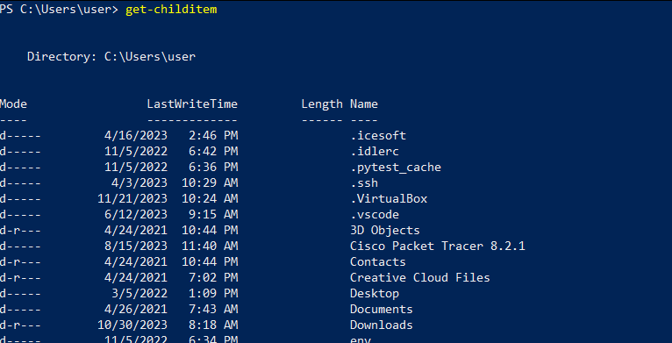

1. What is the purpose of the Clear-Host cmdlet in PowerShell?

The purpose of the clear-host cmdlet in PowerShell is to clear the screen.

1. Using Get-Content, how would you display the contents of a file named “example.txt”?

To display the contents of a file named “example.txt”, get-content “file name” is used. Example;

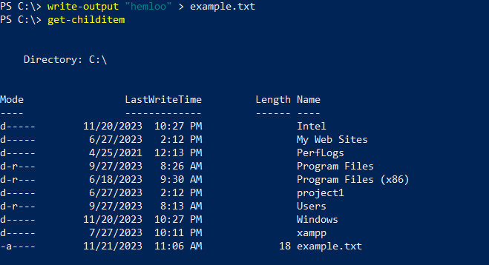

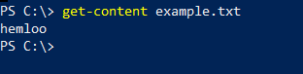

1. Provide three examples of aliases and their corresponding full cmdlet names. Why might aliases be useful in PowerShell?

The examples of aliases are clear 🡪 clear-host, cd 🡪 set-location, cp 🡪 copy-item.

Aliases might be useful in PowerShell as it gets the aliases in the current session.

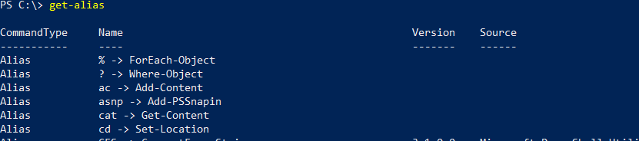

1. Explain how you can run an external command, like “ping” or “Calc,” from within the PowerShell console.

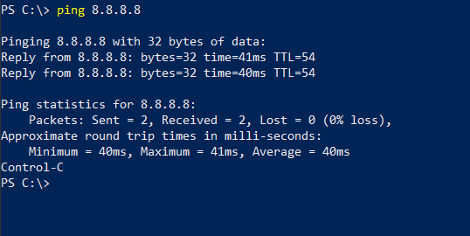

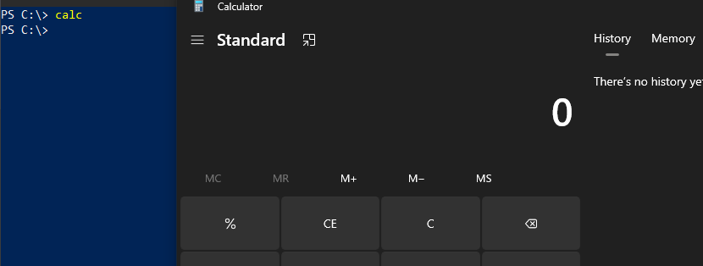

1. What information does the ipconfig /all command provide, and in what scenarios might it be useful?

The ipconfig /all command provide detailed information about all adaptors, including the IP address, subnet mask, default gateway, DHCP server, and DNS servers.

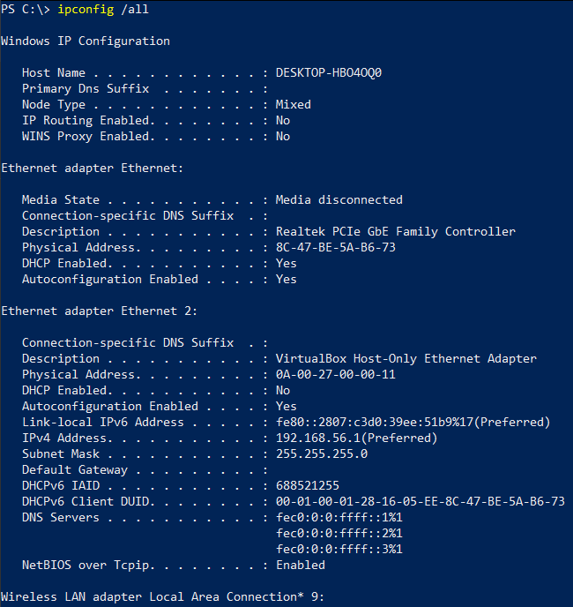

1. Write a PowerShell command to retrieve information about all services on your computer, including the service name, display name, and status.

A PowerShell command to retrieve information about all services is get-service.

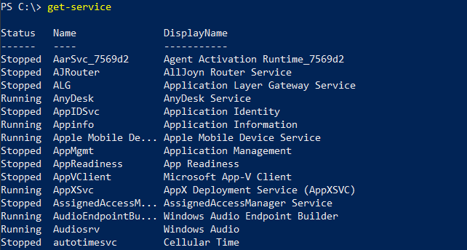

1. What is the purpose of the Update-Help –Force command in PowerShell?

The purpose of the Update-Help –Force command is to update into the newest versions of help topics without downloading new modules or running Window Update.

1. How would you use the Get-Help cmdlet to find general information about all available cmdlets?

Get-help \* would be use to find general information about all available cmdlets.

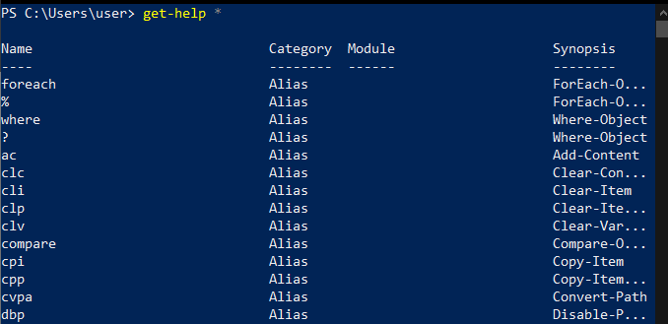

1. List two examples of approved verbs used in PowerShell cmdlet naming.

The examples of approved verbs that is used in PowerShell cmdlet naming;

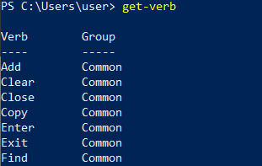

1. How can you view the current directory path in PowerShell?

The current directory path in PowerShell can be viewed by get-location.

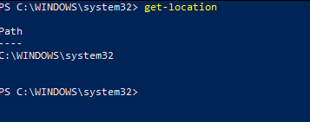

1. Write a command to copy a file named “report.doc” from the current directory to the “Backup” directory.

The command to copy a file named “report.doc” from the current directory to the “Backup” directory is copy-item .\<file name> .\<directory name>

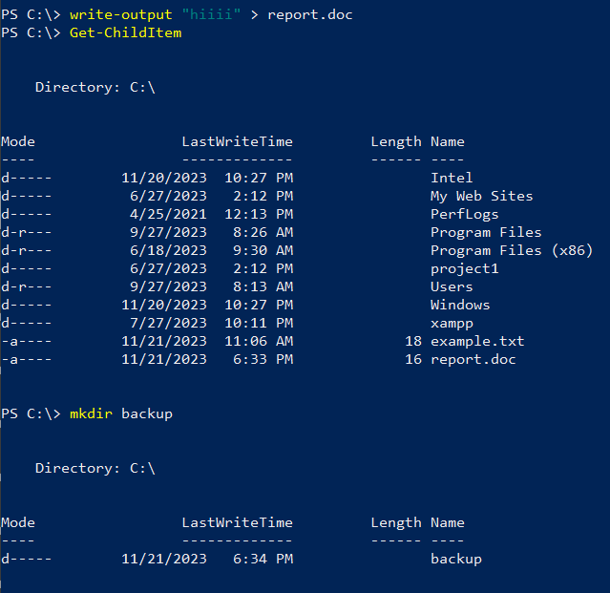

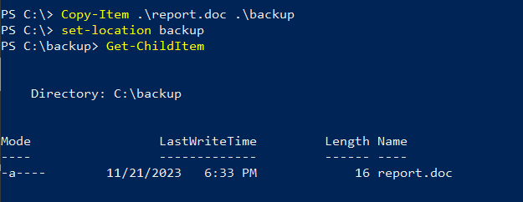

1. Explain the significance of the –Force parameter in the Remove-Item cmdlet.

The significance of the –Force parameter in the Remove-Item cmdlet is to remove items that can’t.

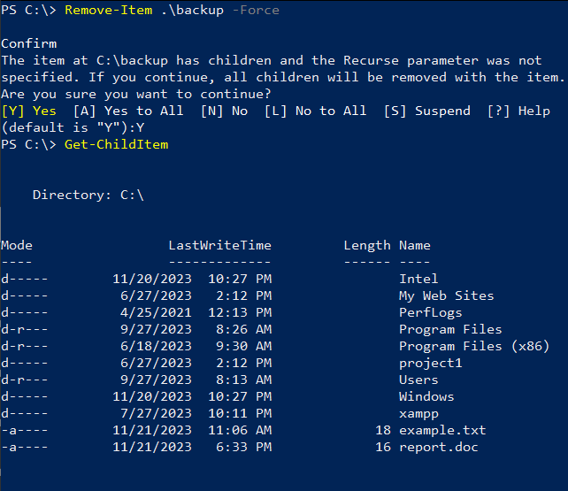

1. Using Get-Help, find detailed information about the Copy-Item cmdlet, including syntax and examples.

Command: get-help copy-item –examples

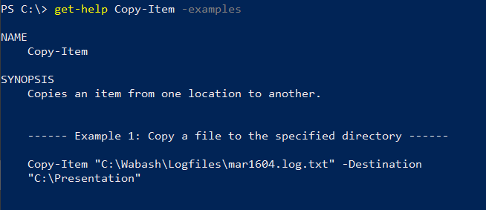

1. How can you open the online help documentation for a specific cmdlet, for example, Get-Service?

Command: get-help get-service -online



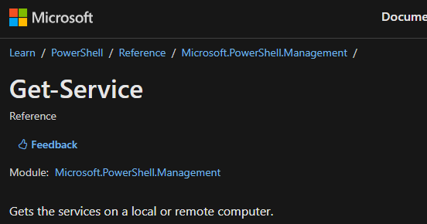

1. Provide an example of a scenario where using an alias in PowerShell might be beneficial.

Using aliases can save time and improve the readability of the scripts, especially when dealing with frequently used cmdlets or long command names. However, it's essential to use aliases judiciously and consider the readability and maintainability of code when doing so.

1. Write a PowerShell command to display all aliases starting with the letter "G."

The command to display all aliases starting with the letter “G” is get-alias \*G\*.

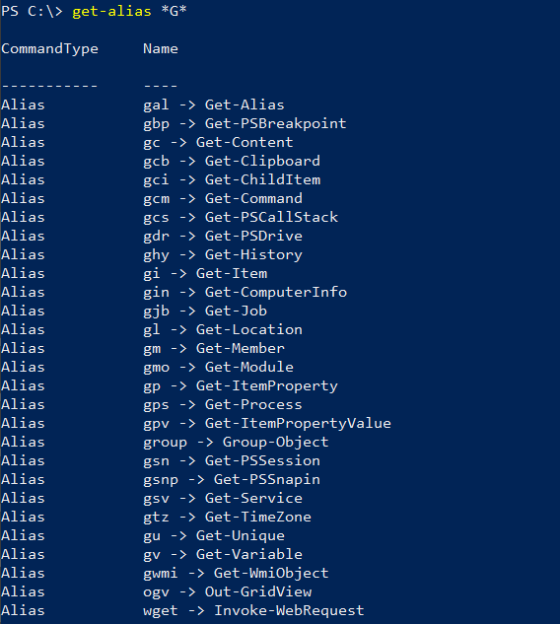

1. Explain the difference between Get-Service and Get-Process in terms of their functionality.

Get-service cmdlet is used to retrieve information about services running on a system. It provides details about Windows services, which are background processes running on the system, often started automatically or manually to perform specific functions.

Get-Process cmdlet is used to retrieve information about running processes in a system. It provides details about the active processes currently running on the system, representing applications, background tasks, oe system processes that are executing.

1. How would you use the Get-Content cmdlet to display only the first 10 lines of a text file named "log.txt"?

By using get-content cmdlet to display only the first 10 lines of a text file named “log.txt” we would use the command get-content –path “log.txt” | select-object –first 10.

